# House Price Prediction using Machine Learning

## Internship Project – Week 1

### Objective
To build a machine learning model that predicts house prices based on various property features and identify the factors that most influence property value.

### Tools Used
- Python
- Pandas
- NumPy
- Scikit-Learn
- Matplotlib
- Seaborn
- Jupyter Notebook / VS Code
import pandas as pd
import numpy as np

import matplotlib.pyplot as plt
import seaborn as sns

from sklearn.model_selection import train_test_split
from sklearn.linear_model import LinearRegression
from sklearn.ensemble import RandomForestRegressor

from sklearn.metrics import mean_absolute_error, mean_squared_error, r2_score

print("Libraries Imported Successfully!")
Libraries Imported Successfully!
df = pd.read_csv("Housing.csv")

print("Dataset Loaded Successfully!")
df.head(10)
Dataset Loaded Successfully!
 | price | area | bedrooms | bathrooms | stories | mainroad | guestroom | basement | hotwaterheating | airconditioning | parking | prefarea | furnishingstatus
0 | 13300000 | 7420 | 4 | 2 | 3 | yes | no | no | no | yes | 2 | yes | furnished
1 | 12250000 | 8960 | 4 | 4 | 4 | yes | no | no | no | yes | 3 | no | furnished
2 | 12250000 | 9960 | 3 | 2 | 2 | yes | no | yes | no | no | 2 | yes | semi-furnished
3 | 12215000 | 7500 | 4 | 2 | 2 | yes | no | yes | no | yes | 3 | yes | furnished
4 | 11410000 | 7420 | 4 | 1 | 2 | yes | yes | yes | no | yes | 2 | no | furnished
5 | 10850000 | 7500 | 3 | 3 | 1 | yes | no | yes | no | yes | 2 | yes | semi-furnished
6 | 10150000 | 8580 | 4 | 3 | 4 | yes | no | no | no | yes | 2 | yes | semi-furnished
7 | 10150000 | 16200 | 5 | 3 | 2 | yes | no | no | no | no | 0 | no | unfurnished
8 | 9870000 | 8100 | 4 | 1 | 2 | yes | yes | yes | no | yes | 2 | yes | furnished
9 | 9800000 | 5750 | 3 | 2 | 4 | yes | yes | no | no | yes | 1 | yes | unfurnished
print("Dataset Shape:")
print(df.shape)

print("\nColumn Names:")
print(df.columns)

print("\nDataset Information:")
df.info()
Dataset Shape:
(545, 13)

Column Names:
Index(['price', 'area', 'bedrooms', 'bathrooms', 'stories', 'mainroad',
'guestroom', 'basement', 'hotwaterheating', 'airconditioning',
'parking', 'prefarea', 'furnishingstatus'],
dtype='object')

Dataset Information:
<class 'pandas.core.frame.DataFrame'>
RangeIndex: 545 entries, 0 to 544
Data columns (total 13 columns):
# Column Non-Null Count Dtype
--- ------ -------------- -----
0 price 545 non-null int64
1 area 545 non-null int64
2 bedrooms 545 non-null int64
3 bathrooms 545 non-null int64
4 stories 545 non-null int64
5 mainroad 545 non-null object
6 guestroom 545 non-null object
7 basement 545 non-null object
8 hotwaterheating 545 non-null object
9 airconditioning 545 non-null object
10 parking 545 non-null int64
11 prefarea 545 non-null object
12 furnishingstatus 545 non-null object
dtypes: int64(6), object(7)
memory usage: 55.5+ KB
print("Missing Values in Each Column:")
df.isnull().sum()
Missing Values in Each Column:
price 0
area 0
bedrooms 0
bathrooms 0
stories 0
mainroad 0
guestroom 0
basement 0
hotwaterheating 0
airconditioning 0
parking 0
prefarea 0
furnishingstatus 0
dtype: int64
df.describe()
 | price | area | bedrooms | bathrooms | stories | parking
count | 5.450000e+02 | 545.000000 | 545.000000 | 545.000000 | 545.000000 | 545.000000
mean | 4.766729e+06 | 5150.541284 | 2.965138 | 1.286239 | 1.805505 | 0.693578
std | 1.870440e+06 | 2170.141023 | 0.738064 | 0.502470 | 0.867492 | 0.861586
min | 1.750000e+06 | 1650.000000 | 1.000000 | 1.000000 | 1.000000 | 0.000000
25% | 3.430000e+06 | 3600.000000 | 2.000000 | 1.000000 | 1.000000 | 0.000000
50% | 4.340000e+06 | 4600.000000 | 3.000000 | 1.000000 | 2.000000 | 0.000000
75% | 5.740000e+06 | 6360.000000 | 3.000000 | 2.000000 | 2.000000 | 1.000000
max | 1.330000e+07 | 16200.000000 | 6.000000 | 4.000000 | 4.000000 | 3.000000
print("Number of Duplicate Rows:", df.duplicated().sum())
Number of Duplicate Rows: 0
df.drop_duplicates(inplace=True)

print("Dataset Shape After Removing Duplicates:")
print(df.shape)
Dataset Shape After Removing Duplicates:
(545, 13)
# Numerical Columns
num_cols = df.select_dtypes(include=np.number).columns

for col in num_cols:
df[col] = df[col].fillna(df[col].median())

# Categorical Columns
cat_cols = df.select_dtypes(include='object').columns

for col in cat_cols:
df[col] = df[col].fillna(df[col].mode()[0])

print("Missing Values Handled Successfully!")
Missing Values Handled Successfully!
df = pd.get_dummies(df, drop_first=True)

print("Categorical Columns Converted Successfully!")
df.head()
Categorical Columns Converted Successfully!
 | price | area | bedrooms | bathrooms | stories | parking | mainroad_yes | guestroom_yes | basement_yes | hotwaterheating_yes | airconditioning_yes | prefarea_yes | furnishingstatus_semi-furnished | furnishingstatus_unfurnished
0 | 13300000 | 7420 | 4 | 2 | 3 | 2 | True | False | False | False | True | True | False | False
1 | 12250000 | 8960 | 4 | 4 | 4 | 3 | True | False | False | False | True | False | False | False
2 | 12250000 | 9960 | 3 | 2 | 2 | 2 | True | False | True | False | False | True | True | False
3 | 12215000 | 7500 | 4 | 2 | 2 | 3 | True | False | True | False | True | True | False | False
4 | 11410000 | 7420 | 4 | 1 | 2 | 2 | True | True | True | False | True | False | False | False
X = df.drop("price", axis=1)
y = df["price"]

print("Features Shape:", X.shape)
print("Target Shape:", y.shape)
Features Shape: (545, 13)
Target Shape: (545,)
X_train, X_test, y_train, y_test = train_test_split(
X,
y,
test_size=0.20,
random_state=42
)

print("Training Data Shape:", X_train.shape)
print("Testing Data Shape:", X_test.shape)
Training Data Shape: (436, 13)
Testing Data Shape: (109, 13)
lr = LinearRegression()

lr.fit(X_train, y_train)

y_pred_lr = lr.predict(X_test)

print("Linear Regression Model Trained Successfully!")
Linear Regression Model Trained Successfully!
mae_lr = mean_absolute_error(y_test, y_pred_lr)

rmse_lr = np.sqrt(mean_squared_error(y_test, y_pred_lr))

r2_lr = r2_score(y_test, y_pred_lr)

print("Linear Regression Performance")
print("MAE :", mae_lr)
print("RMSE:", rmse_lr)
print("R² Score:", r2_lr)
Linear Regression Performance
MAE : 970043.4039201637
RMSE: 1324506.9600914388
R² Score: 0.6529242642153184
rf = RandomForestRegressor(
n_estimators=200,
random_state=42
)

rf.fit(X_train, y_train)

y_pred_rf = rf.predict(X_test)

print("Random Forest Model Trained Successfully!")
Random Forest Model Trained Successfully!
mae_rf = mean_absolute_error(y_test, y_pred_rf)

rmse_rf = np.sqrt(mean_squared_error(y_test, y_pred_rf))

r2_rf = r2_score(y_test, y_pred_rf)

print("Random Forest Performance")
print("MAE :", mae_rf)
print("RMSE:", rmse_rf)
print("R² Score:", r2_rf)
Random Forest Performance
MAE : 1013968.579587156
RMSE: 1398115.6668385956
R² Score: 0.6132752494107068
comparison = pd.DataFrame({
"Model": ["Linear Regression", "Random Forest"],
"MAE": [mae_lr, mae_rf],
"RMSE": [rmse_lr, rmse_rf],
"R2 Score": [r2_lr, r2_rf]
})

comparison
 | Model | MAE | RMSE | R2 Score
0 | Linear Regression | 9.700434e+05 | 1.324507e+06 | 0.652924
1 | Random Forest | 1.013969e+06 | 1.398116e+06 | 0.613275
plt.figure(figsize=(8,5))

sns.histplot(df["price"], bins=30, kde=True)

plt.title("Distribution of House Prices")
plt.xlabel("Price")
plt.ylabel("Frequency")

plt.show()
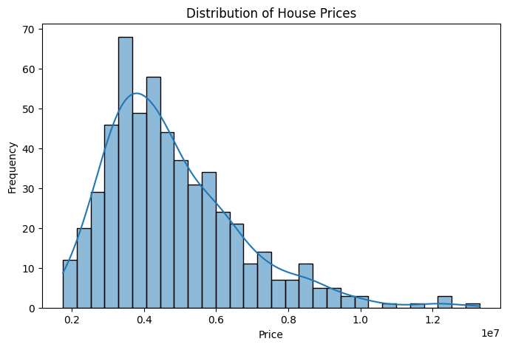plt.figure(figsize=(12,8))

sns.heatmap(
df.corr(),
cmap="coolwarm",
annot=False
)

plt.title("Correlation Heatmap")

plt.show()
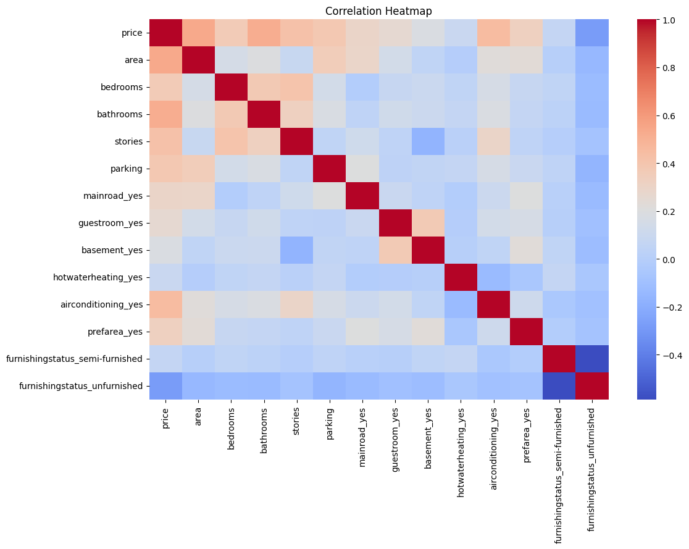plt.figure(figsize=(8,5))

plt.scatter(y_test, y_pred_rf)

plt.xlabel("Actual Price")
plt.ylabel("Predicted Price")

plt.title("Actual vs Predicted House Prices")

plt.show()
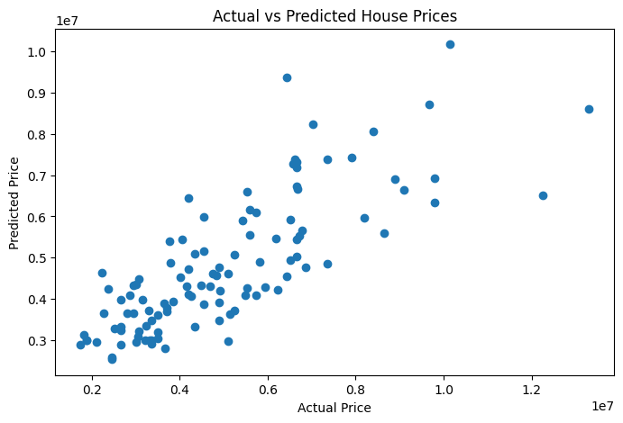feature_importance = pd.DataFrame({
"Feature": X.columns,
"Importance": rf.feature_importances_
})

feature_importance = feature_importance.sort_values(
by="Importance",
ascending=False
)

feature_importance.head(10)
 | Feature | Importance
0 | area | 0.468535
2 | bathrooms | 0.152554
9 | airconditioning_yes | 0.060238
4 | parking | 0.057273
3 | stories | 0.057064
1 | bedrooms | 0.047370
12 | furnishingstatus_unfurnished | 0.036972
7 | basement_yes | 0.032176
10 | prefarea_yes | 0.028432
8 | hotwaterheating_yes | 0.018305
plt.figure(figsize=(10,6))

sns.barplot(
data=feature_importance.head(10),
x="Importance",
y="Feature"
)

plt.title("Top 10 Most Important Features")

plt.show()
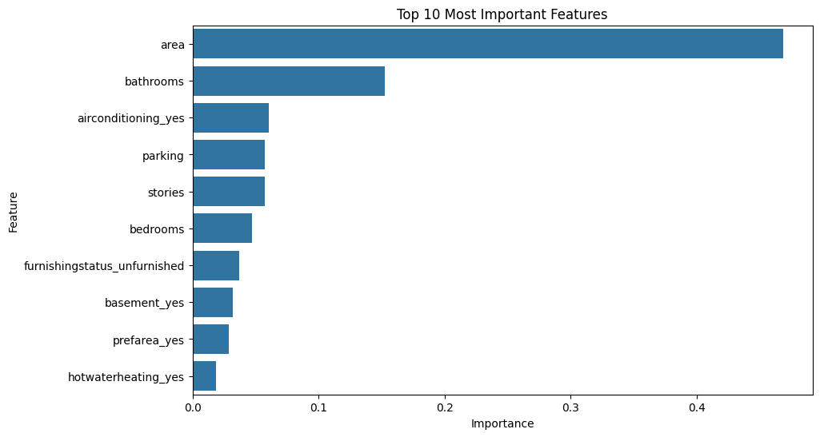# Insights and Summary

1. The area of the house was one of the most influential features affecting house prices.
2. Bathrooms, parking spaces, air conditioning, and preferred area also had a strong impact on pricing.
3. The Random Forest Regressor performed better than Linear Regression, achieving a higher R² score and lower prediction errors.
4. Larger houses generally had higher prices, indicating a strong positive relationship between area and price.
5. The housing prices were slightly right-skewed, meaning a few properties were significantly more expensive than the rest.
6. A real estate company can use this model to estimate fair market prices and improve pricing decisions.
7. The analysis demonstrates how machine learning can assist buyers, sellers, and real estate agencies in understanding property values more accurately.
Cell In[22], line 5
3. The Random Forest Regressor performed better than Linear Regression, achieving a higher R² score and lower prediction errors.
^
SyntaxError: invalid character '²' (U+00B2)

